**S3 Bucket  
===========**

**1) Create s3 bucket and upload some objects to s3.**

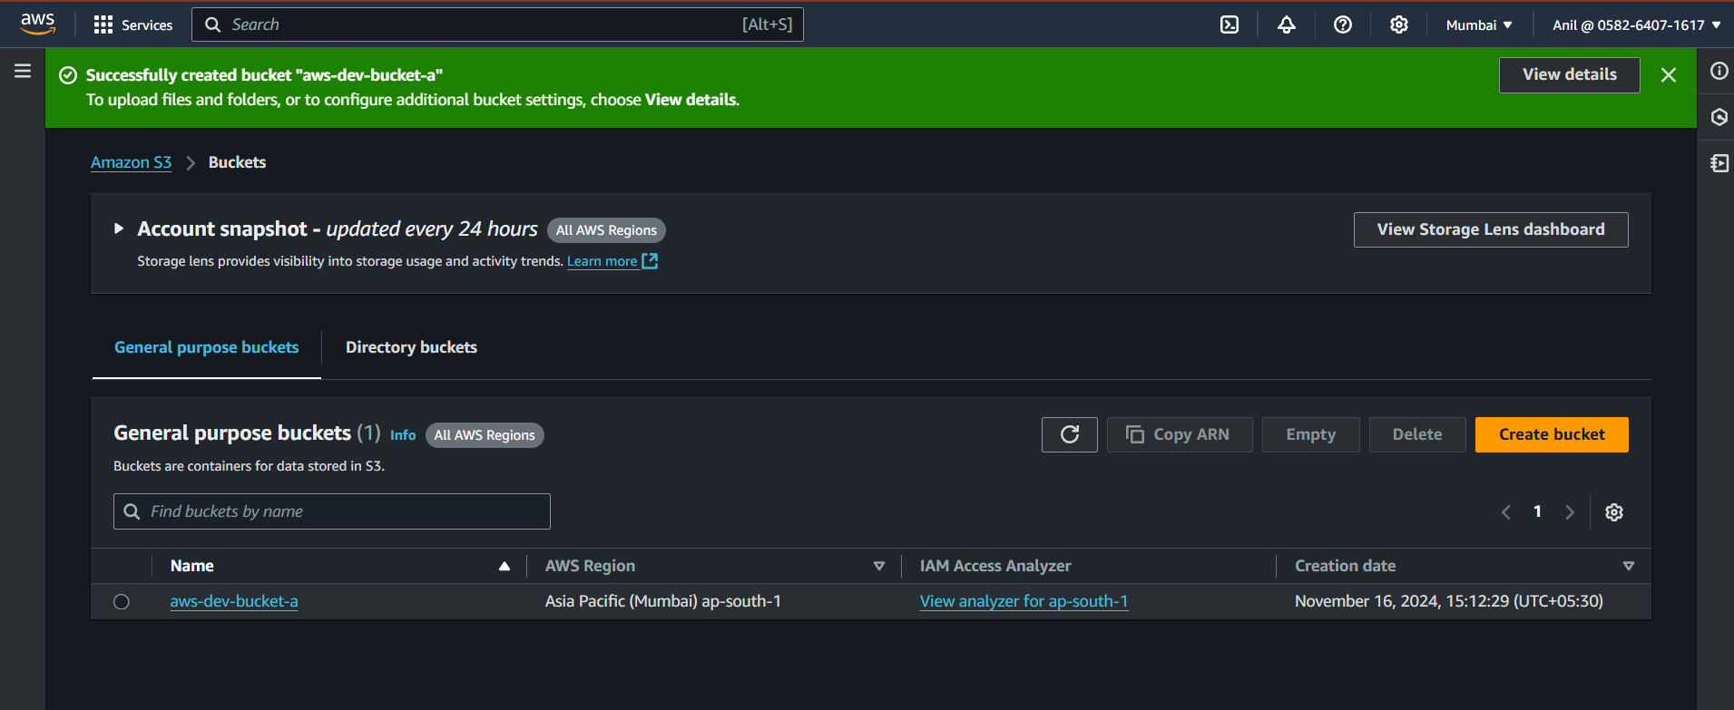

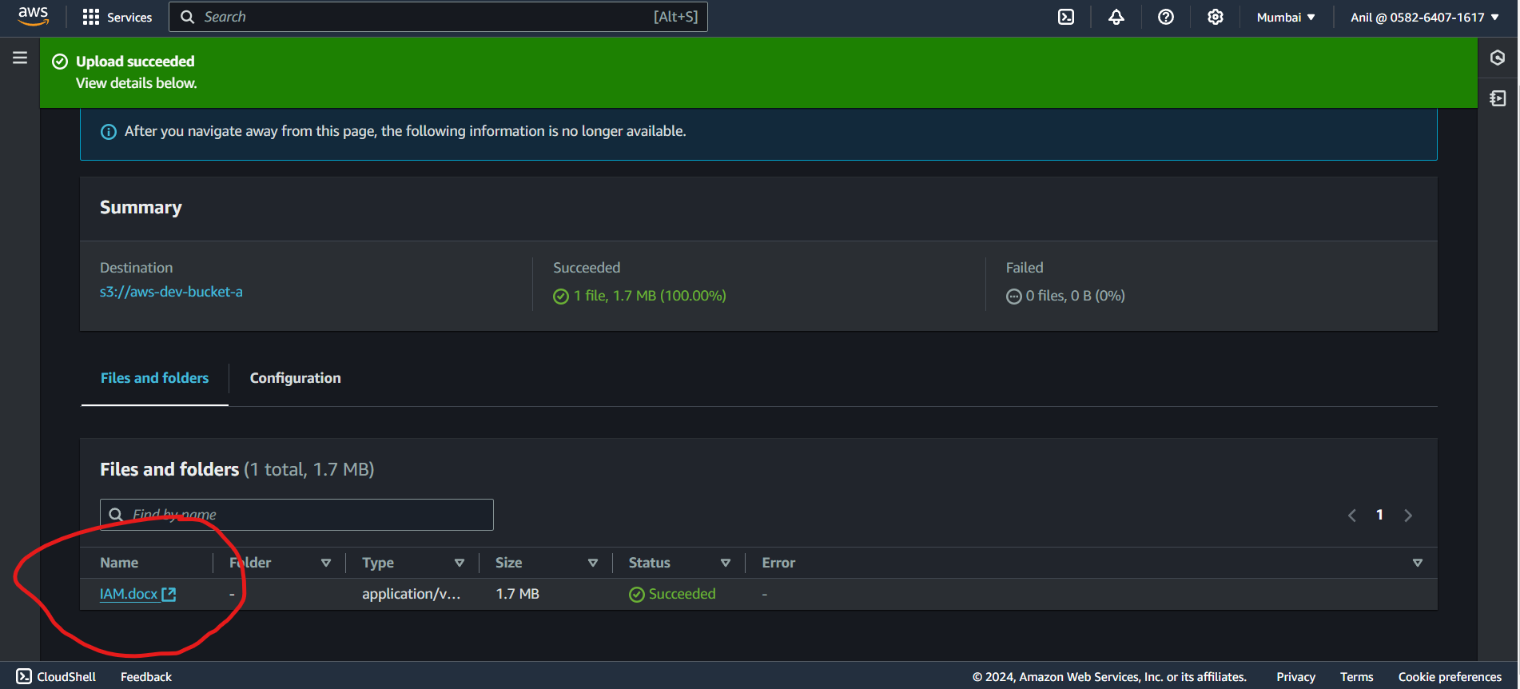

**2) Deploy static website in s3 bucket.**

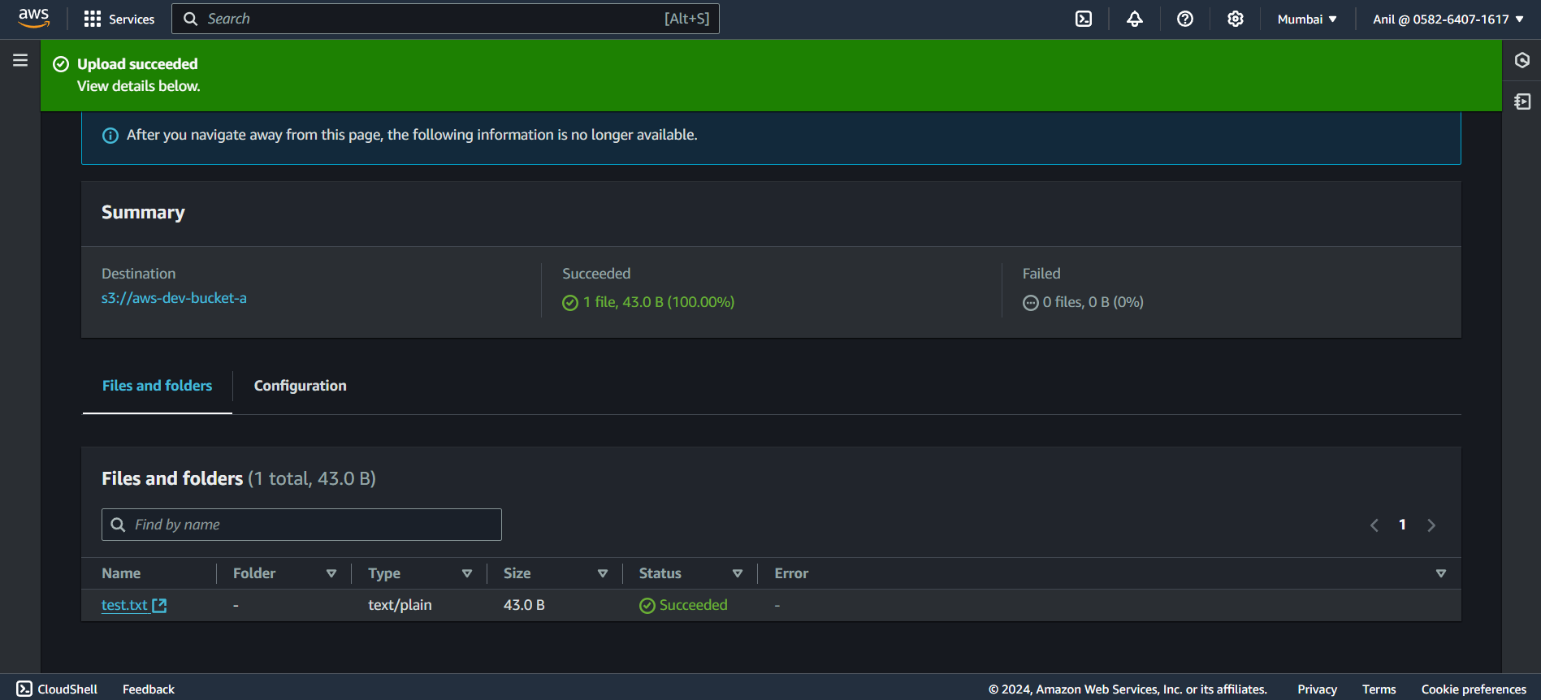

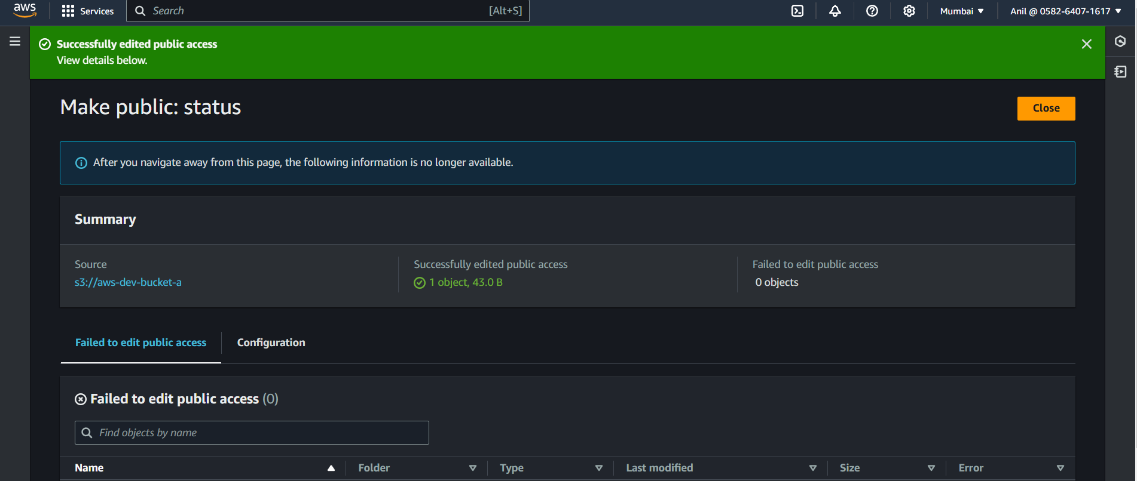

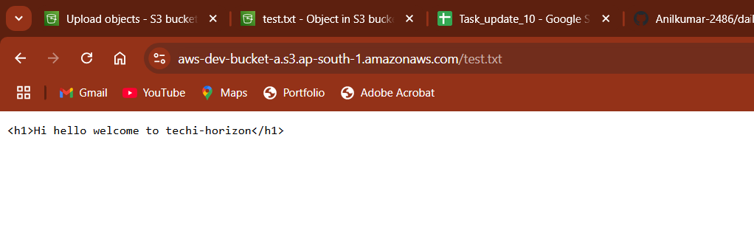

**3)** **Enable cross region replication on s3 buckets.**

1. Enable Versioning on Both Buckets:
   * Go to the S3 console.
   * Select the source bucket.
   * Under Properties, enable Bucket Versioning.
   * Repeat for the destination bucket.

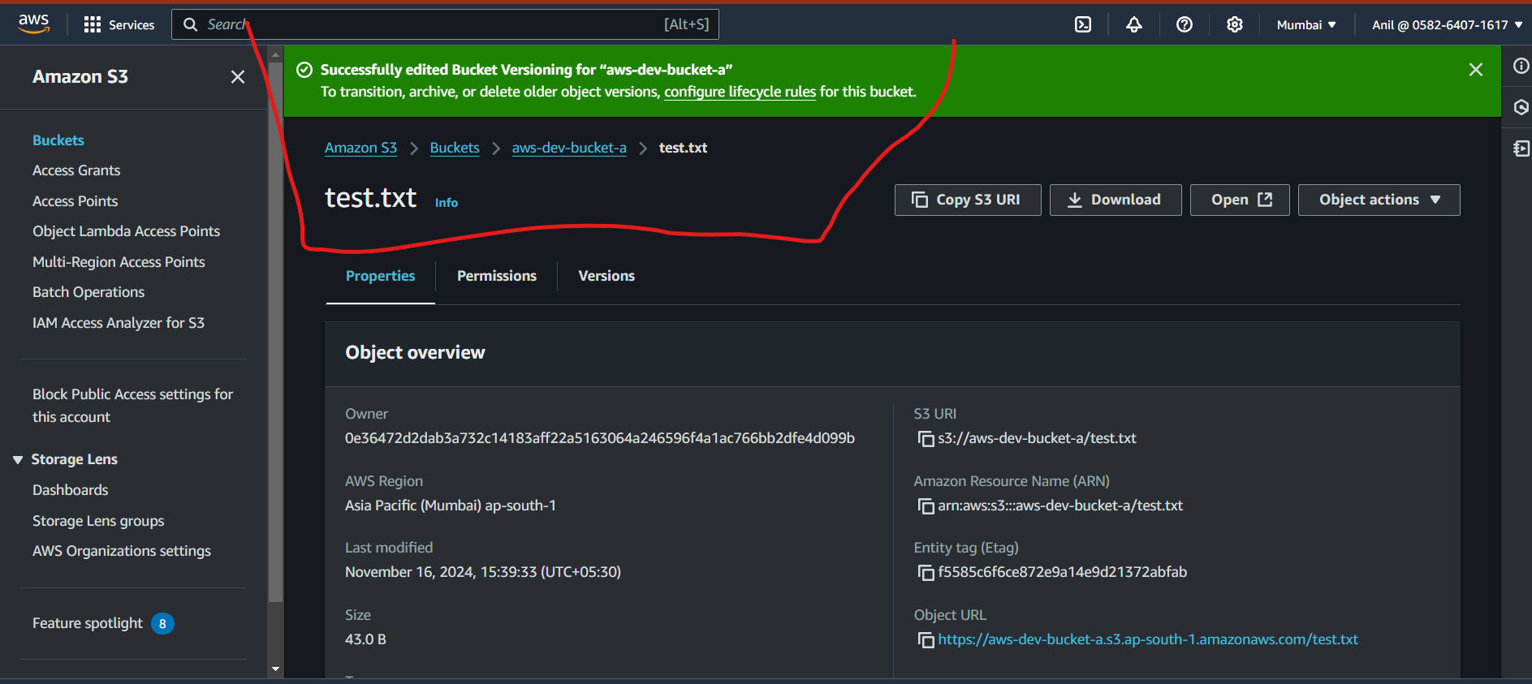

1. Set Up Replication Rules:
   * In the source bucket, go to the Management tab.
   * Under Replication, click Create Replication Rule.
   * Provide a name for the rule.
   * Specify the source bucket objects to replicate (e.g., all objects or objects with a specific prefix or tag).
2. Select Destination Bucket:
   * Choose the destination bucket from the list or enter its ARN.

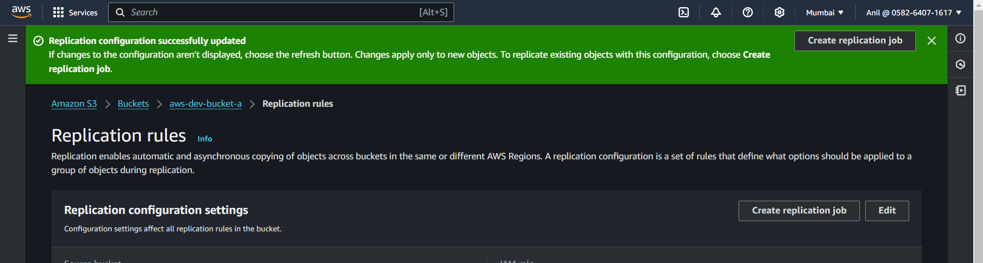

1. Choose IAM Role:
   * Select an existing IAM role or let AWS create a new one for replication.
2. Optional Settings:
   * Enable object ownership override if needed.
   * Choose whether to replicate delete markers and tags.
3. Review and Save:
   * Review the configuration and save the rule.

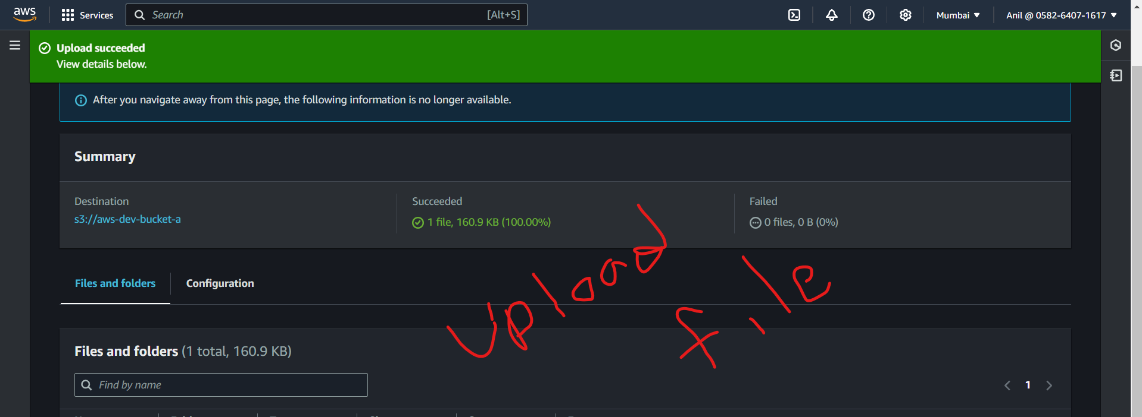

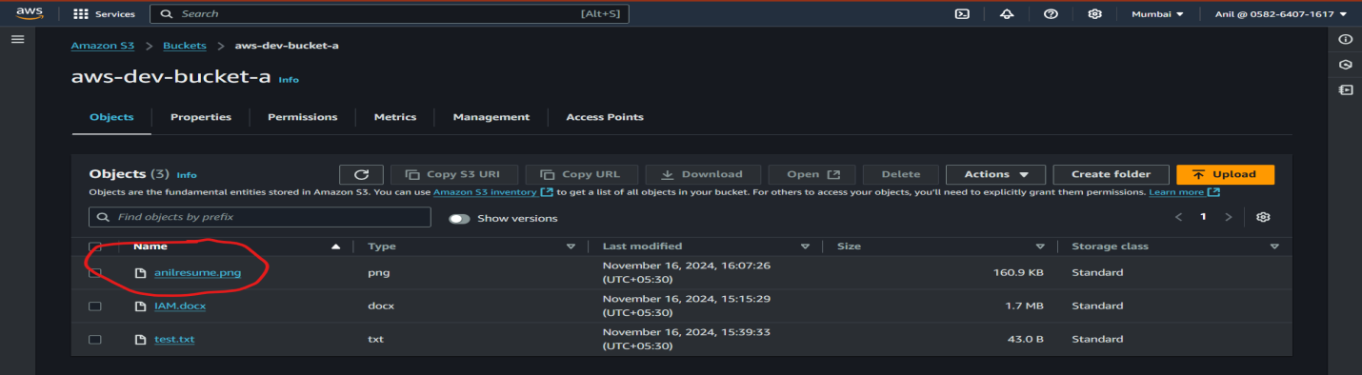

**4)Write a bash script to create s3 bucket.**

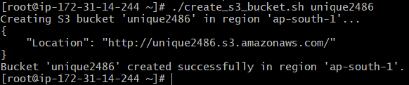

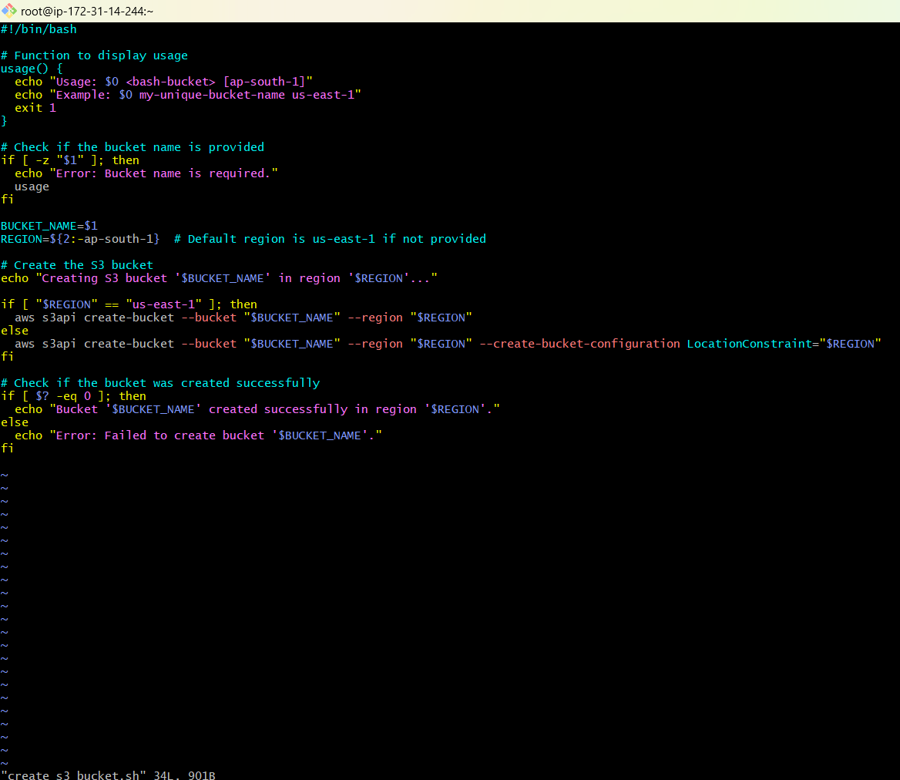

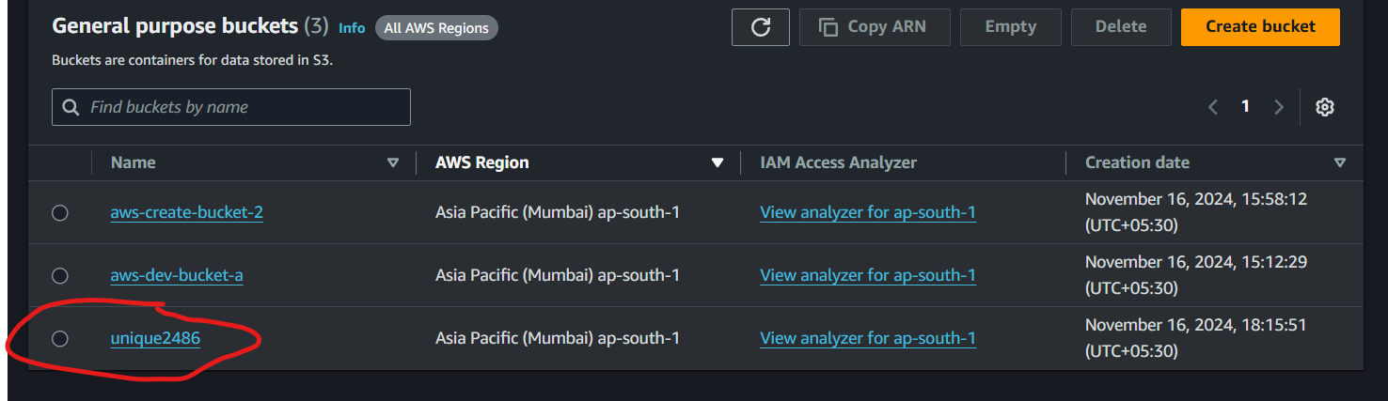

**5)** **Push some objects in s3 using AWS CLI.**

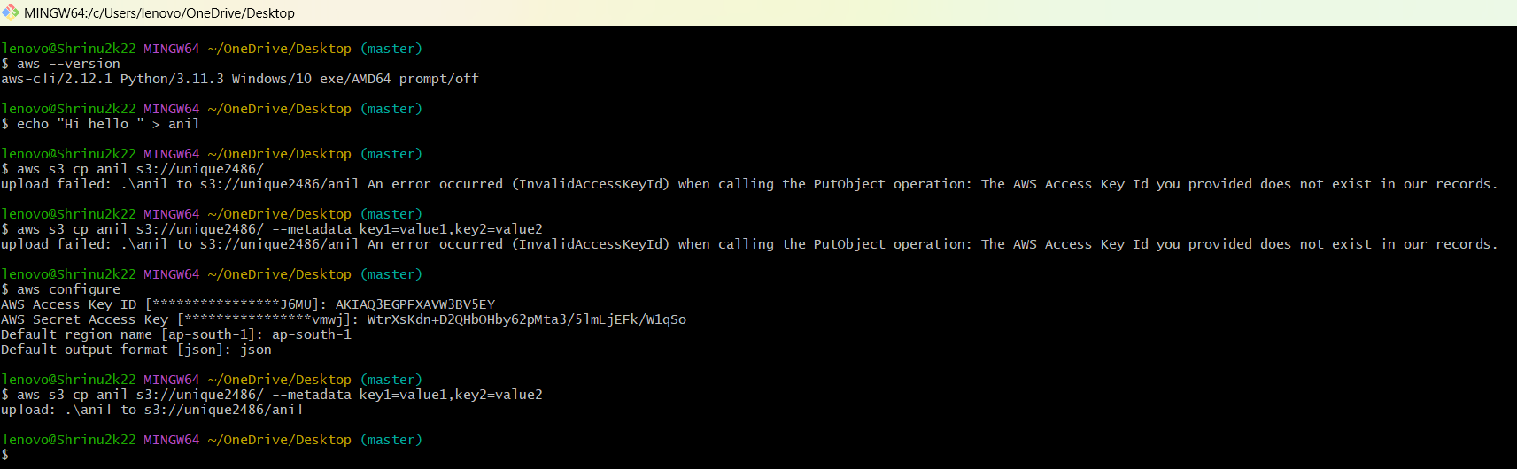

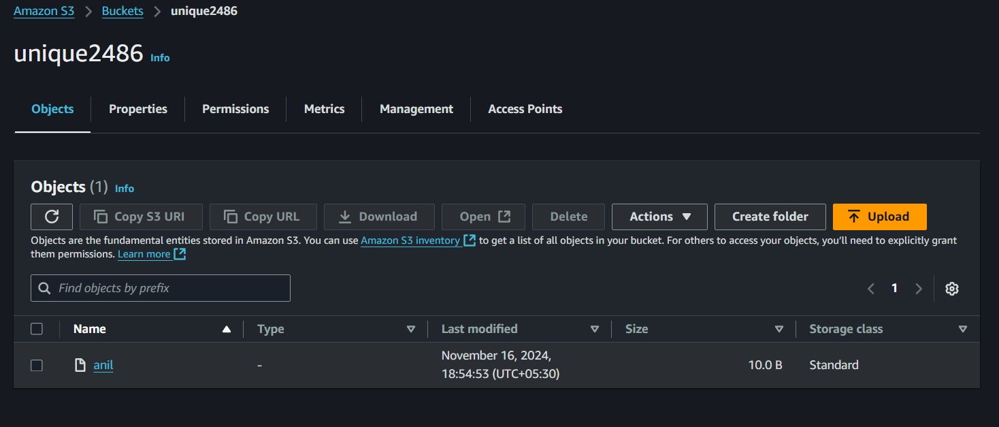

**6) Upload one 1 gb of file to s3 using cli.**

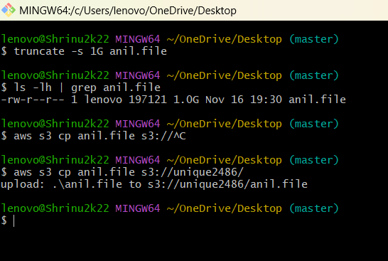

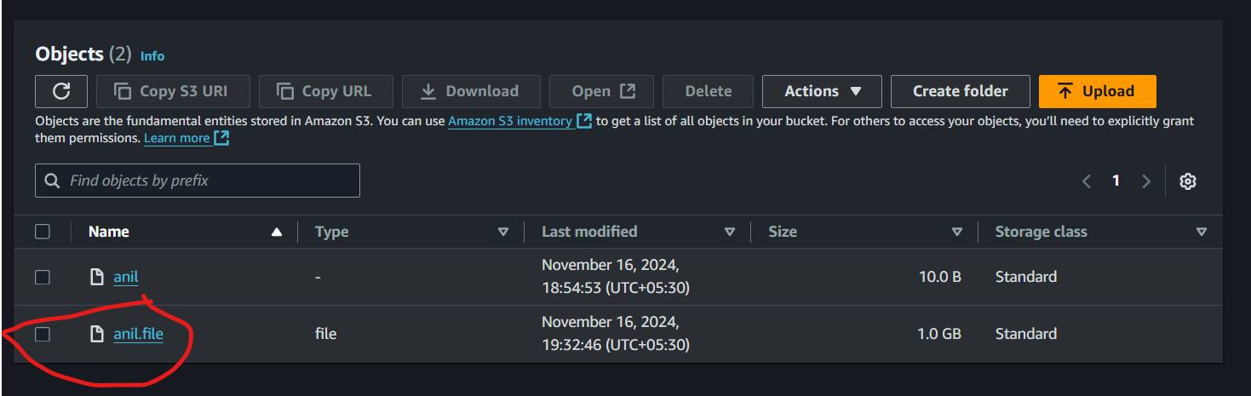

**7)** **Setup lifecycle policies to automatically transition or delete objects based on specific criteria.**

At least one transition or expiration action needs to be defined for the rule. how can i do this

To successfully create a lifecycle rule, you need to include at least one transition or expiration action. Let's go through the steps to define these actions:

1. Log in to the AWS Management Console: Go to the AWS Management Console.
2. Navigate to the S3 Dashboard: In the services menu, search for "S3" and click on it to go to the S3 Dashboard.
3. Select Your Bucket: Click on the bucket for which you want to set up lifecycle policies.

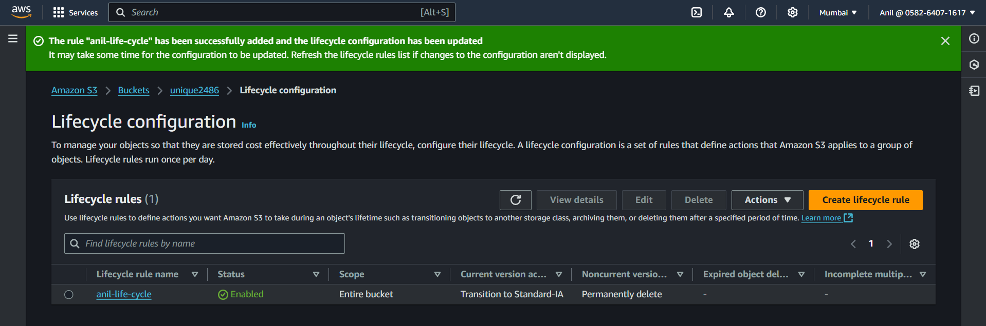

**4) Configure bucket policy,only Admin user can see the objects of s3 bucket.  
